# **1. Regulatory Symbols & Labelling**

|  |  |  |
| --- | --- | --- |
| Symbol (graphic placeholder) | Reference | Usage |
|  | ISO 15223-1:2021 (5.1.1) | Manufacturer: MediCare Tags Limited  Registered in Ireland No 694928  Registered Office: Salthill House, Salthill, Galway, H91W4C6, Ireland. |
|  | ISO 15223-1:2021 (5.7.7) | Medytrak (Medical Device) |
|  | ISO 15223-1:2021 (5.1.6) | Medytrak |
|  | ISO 15223-1:2021 (5.1.3) | Date of manufacture: 2025-10-01 |
|  | ISO 15223-1:2021 (5.7.10) | UDI: 5391550670009 |
|  | ISO 15223-1:2021 (5.4.3) | Consult Instructions for Use at :  https://www.medytrak.com |
|  | EU MDR 2017/745 Annex V | CE marking displayed post-registration |

**Table of Contents**

**1. Regulatory Symbols & Labelling** 1

**2. Regulatory Disclaimer** 4

**2.1 Compliance Note** 4

**3. Introduction** 5

**4. General Use Instructions** 5

**5. Patient Onboarding** 5

**5.1 Practitioner Consent Confirmation and Phone Entry** 5

**5.2 Patient Receives SMS Verification Code** 6

**5.3 Patient Questionnaire Access** 7

**6. Clinician Dashboard** 7

**7. Troubleshooting** 10

**Appendix 1 - Compliance** 11

**Appendix 2 - Intended Use Statement** 13

# **2. Regulatory Disclaimer**

Medytrak Medical Device Data System (MDDS) software is intended to facilitate communication of data and support administration efficiency between adult patients and clinicians.

Medytrak **does not perform any diagnostic, prognostic, or therapeutic functions**. Clinical judgment must always be exercised by the treating physician or healthcare provider when interpreting data collected and displayed by Medytrak.

This system is:

* **Not intended to replace** in-person clinical evaluation, diagnosis, or treatment.
* **Not designed** to control or alter any physiological functions of a patient.
* **Not a substitute** for emergency medical services.

Healthcare professionals are responsible for verifying that the data presented through Medytrak dashboards is interpreted within the context of the patient’s complete medical history, current condition, and established clinical guidelines.

Patients should understand that Medytrak serves as a **communication and data gathering tool** only. It should not be used as the sole basis for medical decisions or as a substitute for professional medical advice.

## **2.1 Compliance Note**

This disclaimer is aligned with international regulatory expectations for Class I Medical Device Data Systems (MDDS), ISO 13485 quality management practices, and IEC 62304 software lifecycle requirements. It is included as part of the regulatory evidence trail to clearly define the intended use, applicable standards, and inherent limitations of the device across global markets.

# **3. Introduction**

Medytrak is a secure medical communication platform designed to empower clinicians with real-time patient data and provide patients with an easy-to-use system for sharing their health information regularly and remotely without the need to travel to clinician offices or hospital settings. This document aims to guide both patients and clinicians to use the user interfaces (forms, screens and dashboards) effectively while ensuring safe, effective, and compliant use of the Medytrak solution.

# **4. General Use Instructions**

• Patients: Complete and submit forms as requested by your provider.  
• Clinicians: Review submitted data through the dashboard for timely interventions.  
• Both: Ensure all notifications are enabled for prompt communication.

# **5. Patient Onboarding**

The onboarding process ensures that patients are securely registered to receive Medytrak services. This process can be completed in under two minutes and requires only a smartphone and confirmation from the practitioner.

## **5.1 Practitioner Consent Confirmation and Phone Entry**



The practitioner enters the patient’s phone number into the Medytrak form and confirms that consent has been obtained. Consent is legally tied to the patient later providing the 5-digit verification code.

## **5.2 Patient Receives SMS Verification Code**

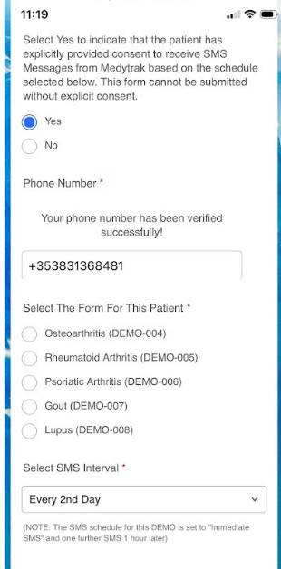The patient receives an SMS message containing a one-time 5-digit code and a link to terms and conditions. The patient must provide this code back to the practitioner to complete onboarding. By doing so, the patient explicitly consents to receiving Medytrak services.

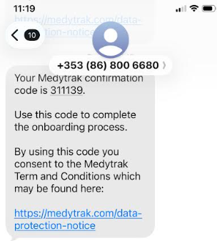

**Note:** The patient is not required to be sitting with the clinician while going through onboarding.

Once onboarded each patient is allocated an unique patient identifier.

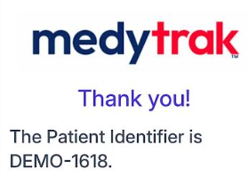

This completes the onboarding process.

## **5.3 Patient Questionnaire Access**

Once onboarding is confirmed, the patient begins receiving SMS messages with links to questionnaires at scheduled intervals as defined by the clinician. These questionnaires capture important clinical data such as symptom tracking, activity limitations, and general well-being. Patients simply follow the SMS link—no application installation is required.

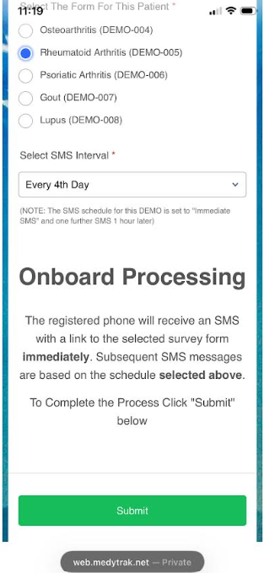

# **6. Clinician Dashboard**

Clinicians access patient data through a centralised secured dashboard. The dashboard provides a comprehensive view of all responses and uploads associated with each unique patient identifier. This allows clinicians to monitor trends, review multimedia submissions (such as photos), and intervene in a timely manner.

The following graphics are example dashboards a clinician would use. Each practice and discipline will have its own requirements.

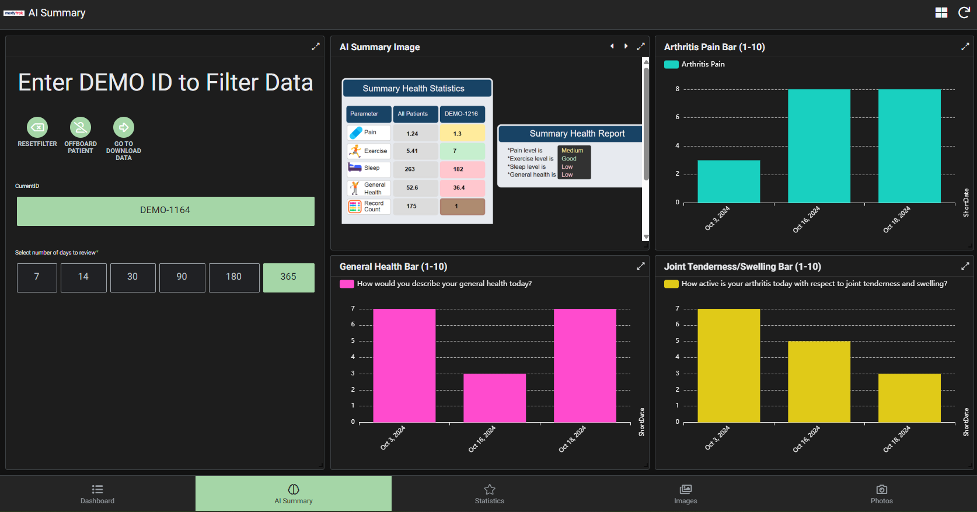

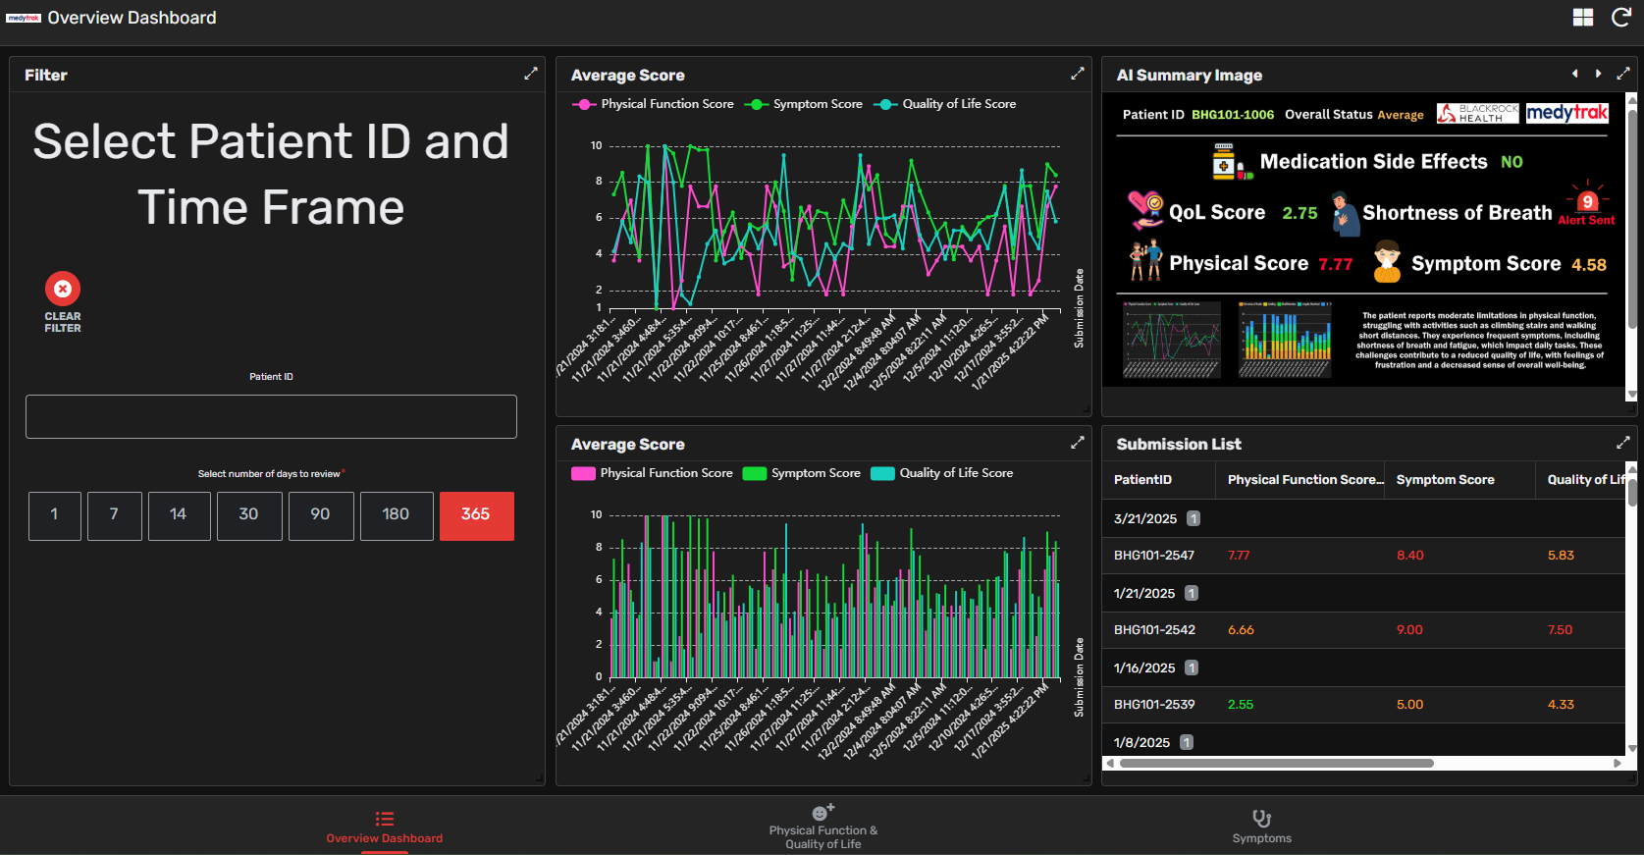

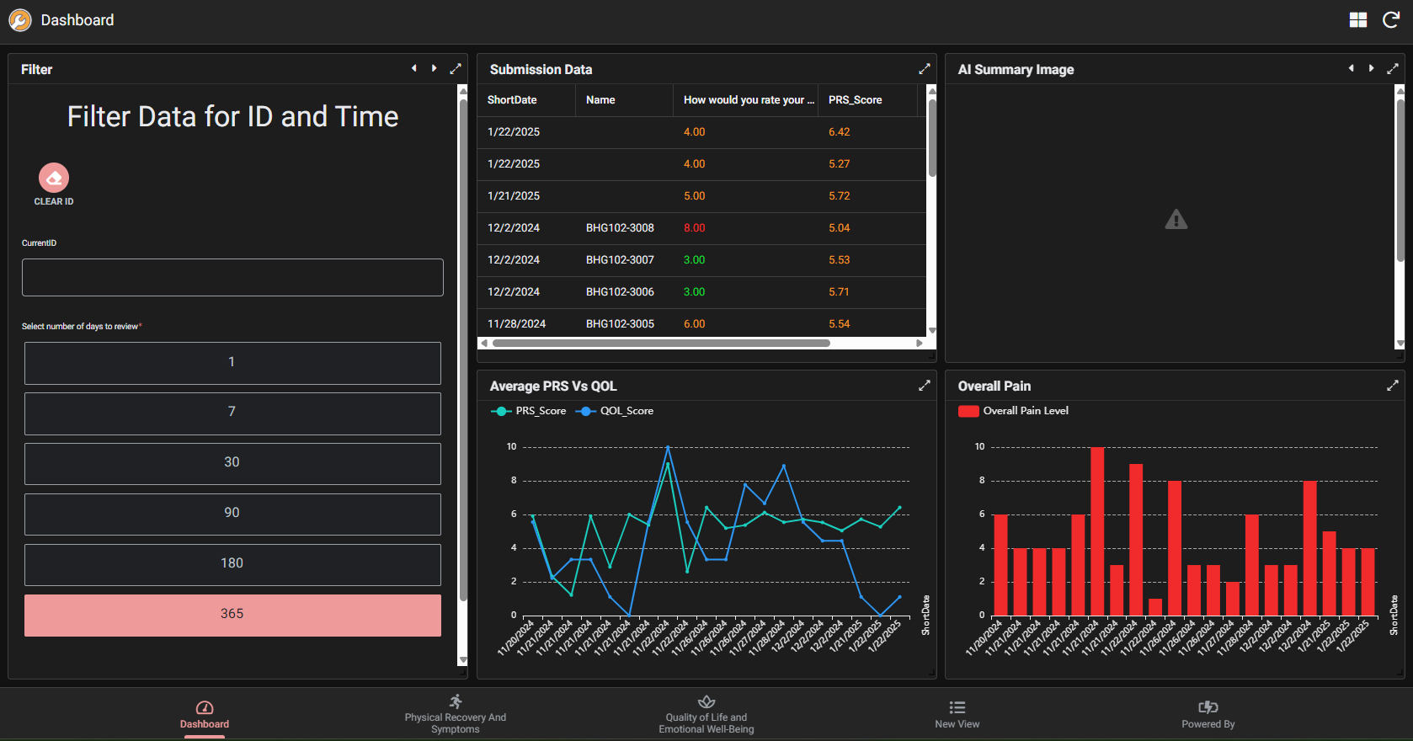

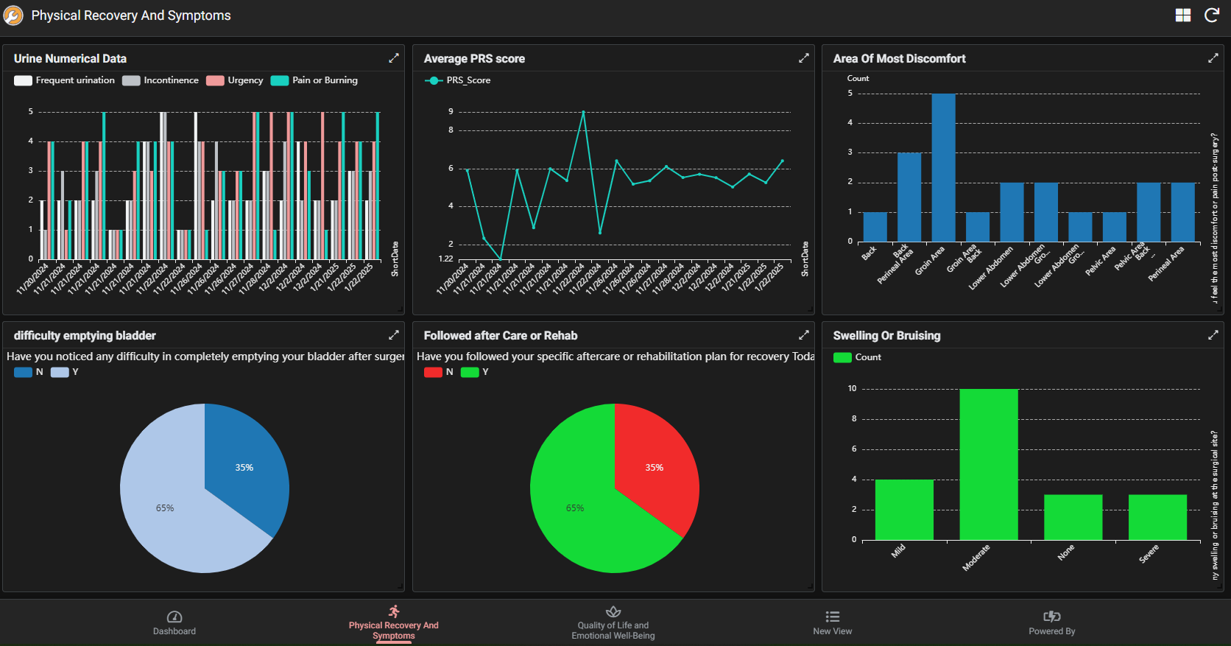

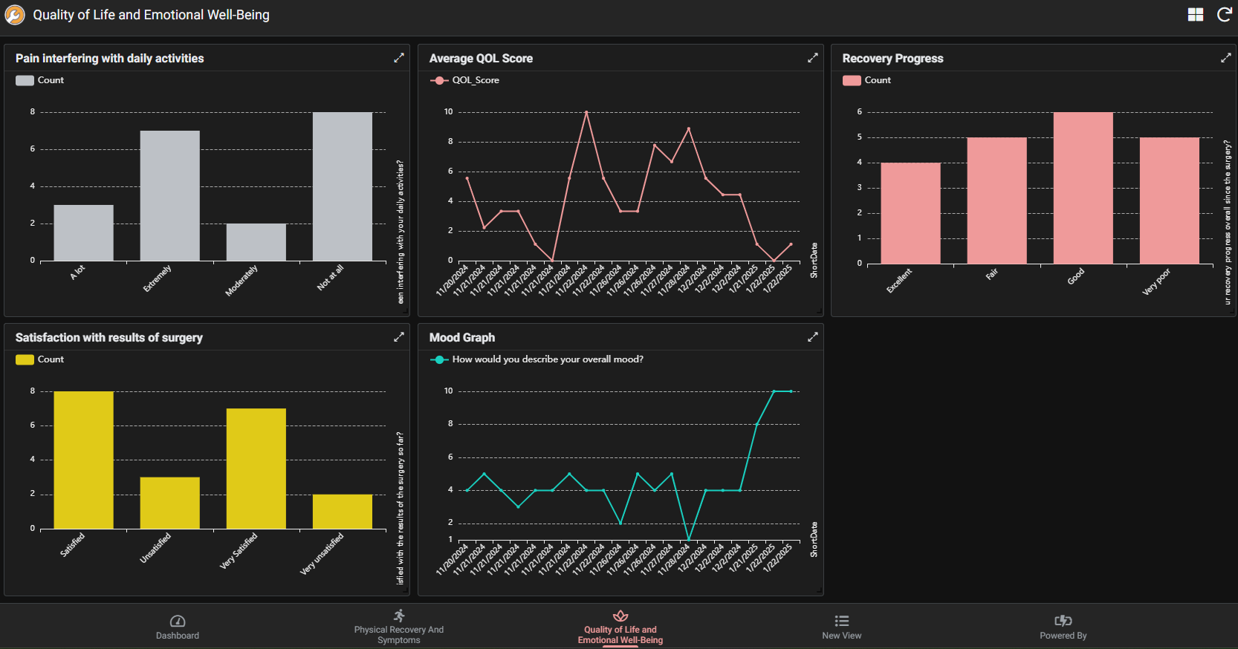

The dashboard is backed by a secure data repository that collects patient information in real-time. Clinicians can filter, analyse, and review patient submissions. Additionally, the data is crafted in a format that may be leveraged for advanced analytics and integration with AI engines for predictive healthcare insights.

# **7. Troubleshooting**

If a user experiences issues:  
- Ensure your device is connected to the internet.  
- **Patients**: Verify you received the SMS or link to access forms.  
- **Clinicians**: Refresh the dashboard to update patient data.  
- Contact Medytrak Support ([support@medytrak.net](mailto:support@medytrak.net)) if problems persist.

# **Appendix 1 - Compliance**

This system is designed in compliance with MDDS Class I SAMD requirements. Clinicians and patients should follow all provided instructions to ensure safe and effective use.

Medytrak has been developed, deployed, and maintained in accordance with applicable regulatory requirements for **Medical Device Data Systems (MDDS) Class I Software as a Medical Device (SaMD)**. To ensure compliance, both clinicians and patients must follow the operational instructions outlined in this document. The following standards and regulations are referenced:

* **21 CFR Part 11** *(U.S. FDA – Electronic Records / Electronic Signatures)*
  + Ensures that electronic health records, logs, and audit trails generated by Medytrak are trustworthy, reliable, and equivalent to paper records.
  + Authentication and audit-trail mechanisms are embedded within the platform.
* **21 CFR 820 (Quality System Regulation)** *(FDA QSR for Medical Devices)*
  + Medytrak is managed under a Quality Management System (QMS) to ensure design controls, validation, verification, and post-market surveillance are observed.
* **ISO 13485:2016 – Medical Devices Quality Management Systems**
  + Development and deployment of Medytrak is carried out within an ISO 13485-aligned Quality Management System (QMS) framework.
  + Emphasis on risk management, traceability, and continuous monitoring to ensure patient safety.
* **ISO 14971:2019 – Application of Risk Management to Medical Devices**
  + All risks associated with data capture, transmission, and storage are systematically identified, evaluated, and mitigated.
  + Patients and clinicians are instructed to report any incidents immediately to ensure corrective actions can be taken.
* **IEC 62304:2006 – Medical Device Software Lifecycle Standard**
  + Medytrak software is developed and maintained under a defined software lifecycle process.
  + Includes planning, requirements management, architecture design, verification/validation, and maintenance.

**• ISO 15223-1:2021 – Medical Devices — Symbols to be Used with Information to be Supplied by the Manufacturer**

* + Medytrak labelling and Instructions for Use apply standardised symbols in accordance with ISO 15223-1:2021.
  + Symbols are selected and justified to ensure clear communication of manufacturer identity, device status, UDI information, and electronic IFU (User Manual) availability.
  + An explanation of all symbols used is provided in the “Regulatory Symbols & Labelling” section of this manual for transparency and user understanding.
* **GDPR (General Data Protection Regulation – EU) & HIPAA (Health Insurance Portability and Accountability Act – U.S.)**
  + Patient data privacy and security are central to Medytrak operations.
  + All personal health information (PHI) is encrypted in transit and at rest, with access limited to authorized clinicians.

**Important User Notes**

* Clinicians must use Medytrak dashboards only within authorised medical contexts, ensuring that the patient’s consent has been obtained prior to onboarding.
* Patients should review and accept the terms and conditions presented during SMS onboarding to ensure compliance with privacy regulations.
* Both clinicians and patients are responsible for reporting anomalies, malfunctions, or suspected security issues to Medytrak support for investigation under the QMS framework.

**Adherence statement**

By adhering to these compliance standards, Medytrak ensures that its use as an MDDS Class I SaMD device is safe, effective, and audit-ready. The operational practices described in this document form part of the compliance evidence trail required during regulatory inspections.

# **Appendix 2 - Intended Use Statement**

**Device Name:** Medytrak  
**Device Classification:** Medical Device Data System (MDDS), Class I, Software as a Medical Device (SaMD)

**Intended Use**

Medytrak Medical Device Data System (MDDS) software is intended to facilitate communication of data and support administration efficiency between adult patients and clinicians.

**Intended Users**

* **Patients**: Individuals under medical care who are required to provide self-reported health data.
* **Clinicians**: Licensed healthcare providers, including physicians, nurses, and allied health professionals, who monitor and analyse patient-submitted information.

Medytrak provides a secure platform for the **collection, storage, transmission, and display of patient health information**. It enables healthcare providers to receive patient-reported outcomes, monitor progress over time, and maintain effective communication with patients outside of the clinical environment.

The system supports:

* Patient onboarding through secure consent and mobile phone–based registration.
* Delivery of digital questionnaires to patients via SMS.
* Collection of patient responses, including text and multimedia data (e.g., photos).
* Centralized dashboards for clinicians to review patient-submitted data.

**Intended Clinical Environment**

Medytrak is intended for use in outpatient, hospital, primary care, and telemedicine settings where secure communication between patients and clinicians is required.

**Limitations of Use**

* Medytrak **does not diagnose, treat, or prevent disease**.
* Medytrak is **not intended for real-time critical monitoring** or emergency response.
* Clinical decisions must not be based solely on Medytrak data; professional medical judgment is required.

**Regulatory Reference**   
This Intended Use Statement is provided in alignment with:

* FDA MDDS Guidance (21 CFR 880.6310, Class I)
* ISO 13485:2016 (Quality Management)
* IEC 62304:2006 (Software Lifecycle Standard)
* ISO 14971:2019 (Risk Management)
* ISO/IEC 27001:2022 (Information Security Management Systems – ISMS)
* ISO 15223-1:2021 (Medical Devices manufacturer Symbols)
* EU MDR 2017/745